EXECUTIVE GAME THEORY CURRICULUM • 12-WEEK MASTER ARCHITECTURE
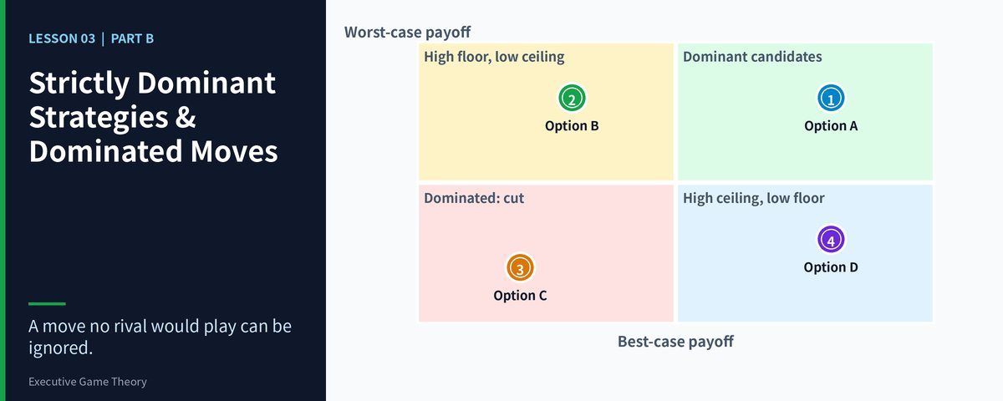

Lesson 03: Strictly Dominant Strategies & Dominated Moves
Intuitive Reinforcement & Strategic Inversion — Eliminate the Losers First: Iterated Deletion and the Limits of Rival Rationality
Strategic Focus & Learning Objective: In this topic, we will be learning how to apply Iterated Elimination of Strictly Dominated Strategies (IESDS) with the Inversion Reflex to solve the Rationality Overconfidence Blind Spot (assuming every rival will play only sensible moves, or ignoring that a sensible rival would never play several of its own options).
The Real-World Operational Problem: Executives either stop at the first deletion, leaving a grid that is still too large to read, or they push the logic too far and treat a rival's irrationality as impossible. Both errors are expensive. Stopping early wastes the biggest benefit of dominance, which is that deleting one player's bad option can expose a bad option for the other player. Over-trusting the logic exposes the firm when a rival, for reasons of ego, error or desperation, plays a move that theory says it never should.
How This Topic Solves It: Inversion starts from deletion. First remove everything that no rational player would choose, for both sides. Then re-read the smaller grid from the rival's side, because deleting your own dominated moves often turns one of the rival's moves into a dominated move too. Repeat until nothing is left to delete. Finally, stress test the answer by asking what happens if a rival ignores the logic. This gives you both the equilibrium and the boundary of your confidence in it.
■ EXECUTIVE INVERSION ADVISORY
Before choosing a move, delete moves. Before trusting the equilibrium, test it against a rival who does not play by the book. The first protects you from wasted effort; the second protects you from misplaced confidence.

Part I: The 4-Part Prelude Protocol
1. Models in Focus: Iterated deletion, dominance solvability, order of deletion, common knowledge of rationality, and the cost of misjudging rival rationality.
2. Lifelike Dilemma & Problem Statement: Two bidders, Firm A and Firm B, compete for an infrastructure services contract. Each has three tactical options. A new CFO at Firm A insists on modelling the rival's "best move" and builds a forty-tab spreadsheet. A bid strategist instead deletes dominated options in turn: first one of Firm B's options is worse than another in every row, then one of Firm A's own options becomes dominated once that column is gone, and the grid collapses to a single cell in four steps. Firm A bids accordingly and wins. Two years later, against a rival under investor pressure that bids irrationally, the same procedure is applied with false confidence and the firm loses badly.
3. Component Dissection: Firm A's procedure was correct. Its mistake in the second episode was to treat the procedure as a law of nature instead of a conditional prediction. IESDS predicts the outcome only if every player is rational and each knows the other is rational. When that belief is doubtful, the equilibrium becomes a benchmark rather than a forecast.
4. Lesson Embarkation: This lesson shows you how to run iterated deletion across both players, in the right order, and how to stress test the result against rivals who may not be rational.

Part II: The 7-Stage Core Pedagogy

Stage 1: Why Learn This (The 45-Second Operational Hook)
Dominance is powerful because it is contagious. Once one of your rival's options is deleted, the remaining grid is smaller, and options that were safe in a large grid may now be dominated in the small one. A manager who stops after one deletion has done a quarter of the work. A manager who iterates to the end often discovers that the whole game has a single logical outcome and that the "debate" was a calculation.
▼ CHECKPOINT: WHAT YOU MUST KNOW BEFORE MOVING FORWARD
Deletion is contagious. Every option you remove can make another option dominated. Keep going until the test finds nothing more to delete, then read what remains.

Stage 2: The 5-Minute Core Framework (The Iterated Deletion Framework)
Consider this 3 × 3 tender grid. Each cell shows (Firm A rank, Firm B rank), where 4 is best and 1 is worst. Firm A chooses a row, Firm B chooses a column. We delete in four rounds.
Firm A \ Firm B | B1: Walk away | B2: Match price | B3: Bundle and undercut
A1: Premium bid | (2, 1) | (2, 3) | (3, 3)
A2: Bundled-service bid | (2, 1) | (4, 1) | (4, 3)
A3: Low-price bid | (1, 2) | (4, 3) | (3, 4)

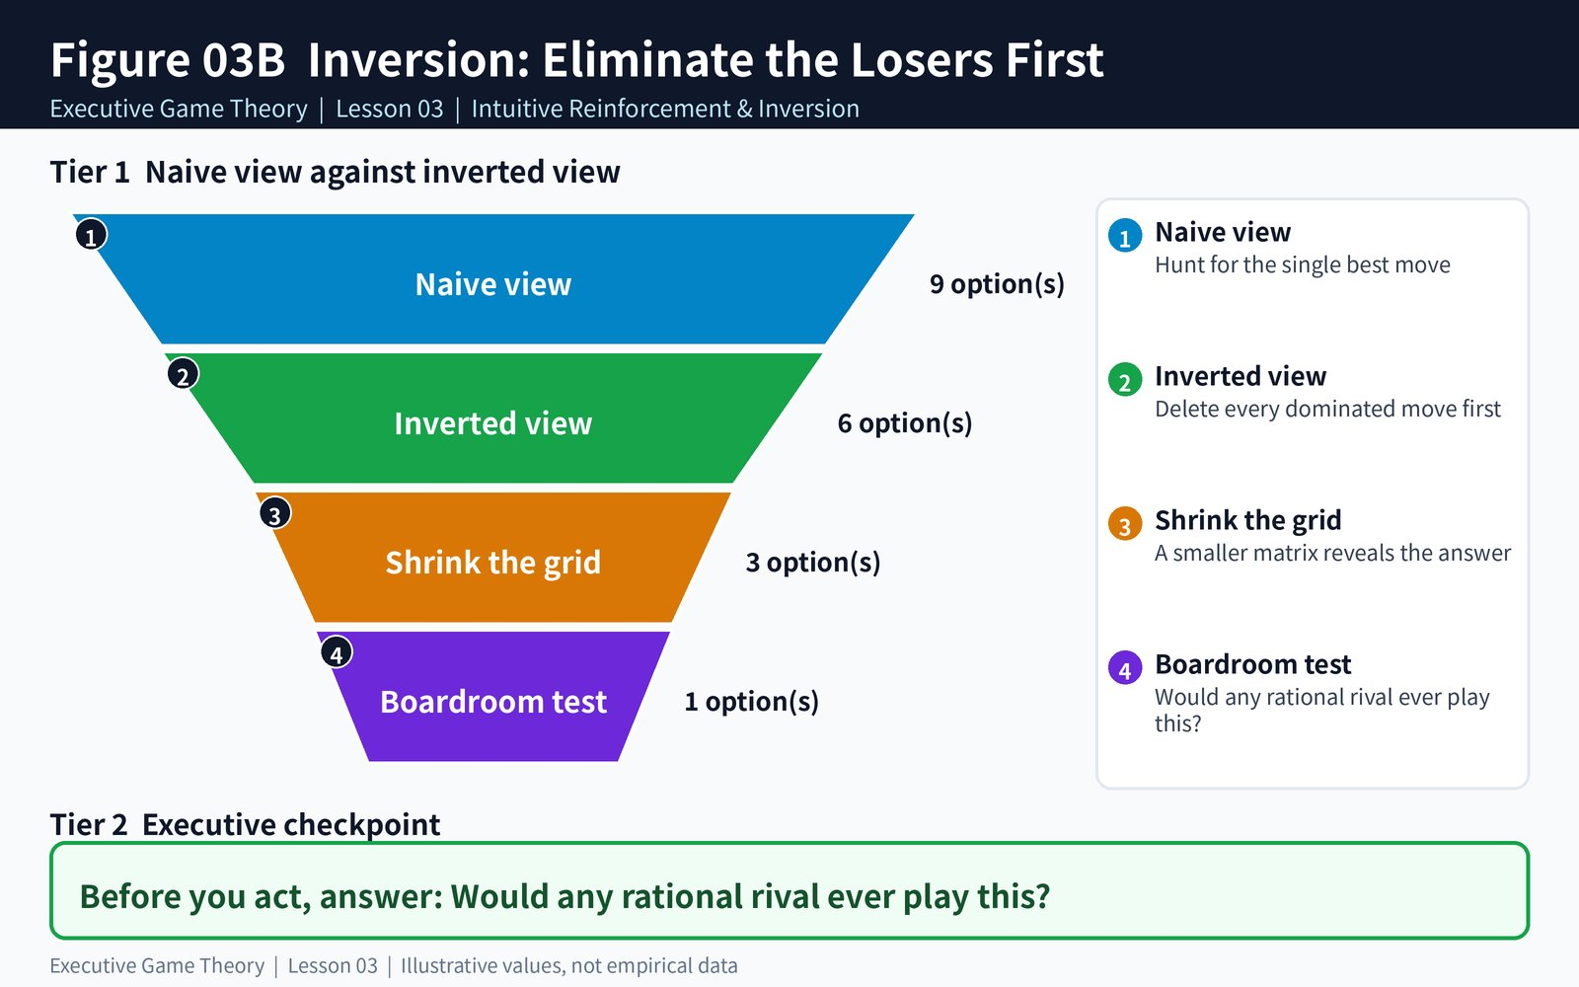
Figure 3B: Inversion — Eliminate the Losers First
Figure 3B: Inversion — Eliminate the Losers First (delete dominated moves, shrink the grid, re-read it from the rival's side)
Round 1: B3 beats B1 in every row (3 > 1, 3 > 1, 4 > 2), so Firm B never walks away. Delete B1. Round 2: with B1 gone, A2 beats A1 in both remaining columns (4 > 2, 4 > 3). Delete A1. Round 3: with A1 gone, B3 beats B2 in both remaining rows (3 > 1, 4 > 3). Delete B2. Round 4: only column B3 remains, where A2 earns 4 and A3 earns 3. Delete A3. The surviving cell is (A2, B3) = (4, 3). Nine options became one in four deletions, and neither player ever needed a forecast.
▼ CHECKPOINT: WHAT YOU MUST KNOW BEFORE MOVING FORWARD
Write down each round: which option, which dominator, and in which columns. If you cannot write the justification in one line, the deletion is not safe.

Stage 3: The 3-Layered Operational Deep Dive
• Layer 1 — The Two-Sided Deletion Protocol: Run the dominance test on your options, then on the rival's options, then back on yours. Delete one dominated option at a time and re-test after each deletion. Record the order of deletion, because with strict dominance the final answer does not depend on it, but your audit trail does.
• Layer 2 — The Rationality Overconfidence Blind Spot: IESDS assumes every player is rational and knows the others are rational. A rival under investor pressure, a founder protecting ego, or a team reacting to bad information may play a dominated move. Treat the iterated result as the answer if your rivals are rational, and keep a fallback plan for the case where they are not.
• Layer 3 — Boundary Conditions: When the test stops with several options left, the game is not dominance solvable and you need a different tool such as best-reply analysis (Nash equilibrium). Weak dominance, ties, and mixed strategies all complicate the picture, and deleting weakly dominated options can change which equilibria survive, so use weak dominance as a warning light and not as a deletion order.
▼ CHECKPOINT: WHAT YOU MUST KNOW BEFORE MOVING FORWARD
Delete one option at a time, record every step, and name the point at which your logic depends on the rival being rational. That point is your risk.

Stage 4: Real-World Applications × 3
1. Public Procurement (Tender Chains): A services firm uses four-round deletion to show that its rival would never submit the abnormally low bid it had feared, and prices at a margin 6 points higher than its first plan, winning on quality scoring.
2. Airline Alliances (Capacity Games): A carrier realizes that a rival's expansion option is dominated once a specific airport slot is secured, and secures that slot before the rival reconsiders. The rival's grid shrinks to the choice the carrier wanted.
3. Labor Negotiations (Offer Sequencing): A management team removes two union demands that are dominated by a third in every scenario, then discovers that the union's own best remaining move is acceptance of the compromise it actually wanted.
▼ CHECKPOINT: WHAT YOU MUST KNOW BEFORE MOVING FORWARD
Run the deletion on both sides of the table. The most valuable insight is often what your rival's grid looks like after you remove your own dominated moves.

Stage 5: Diagnostic Self-Quiz & Evaluative Rubric
Scenario: In a three-by-three game you delete one of your own dominated options. Which of the following is the best next step?
A) Stop, because dominated moves have been removed. B) Re-run the dominance test on your rival's options in the smaller grid, because options that were not dominated before may be now. C) Assume the rival will play its highest-payoff cell. D) Average the remaining payoffs and choose the best average.
Recommended Answer —B: Deleting an option shrinks the grid, and an option that survived in the large grid can become strictly dominated in the smaller one. That is why the test is iterative. Stopping early (A) wastes the benefit, assuming the highest cell (C) ignores the rival's own incentives, and averaging (D) confuses dominance with expected value.
▼ CHECKPOINT: WHAT YOU MUST KNOW BEFORE MOVING FORWARD
After every deletion re-run the test for both players. The grid you are reading is no longer the grid you started with.

Stage 6: What You Should Know by Now (Daily Life Translation)
■ THE DAILY LIFE TRANSLATION
Booking a family holiday is iterated deletion. You cross off the destinations that no one wants, which makes it obvious that two options are now unaffordable once the flights are fixed, and the list collapses until one choice remains. But if your teenager decides to ignore the logic and refuse to travel at all, your clean deletion plan meets a player who is not playing by the same rules.

▼ CHECKPOINT: WHAT YOU MUST KNOW BEFORE MOVING FORWARD
Logic gives you the answer for rational players. Daily life, and business, include people who are tired, proud or afraid. Hold the equilibrium firmly and your confidence in it loosely.

Stage 7: Self-Regulated Practice & Interactive Discovery
Choose a negotiation or bid you will face this quarter. Build the 3 × 3 grid from both sides, run the deletion rounds in writing, and mark the round where you most rely on the rival being rational. Prepare a one-line fallback for that round. Then test your instincts in the two companion games below.
▼ CHECKPOINT: WHAT YOU MUST KNOW BEFORE MOVING FORWARD
A fallback written before the meeting costs one minute. A fallback improvised in the meeting usually costs the deal.

Topic 03 Companion Games: Operational Briefing & Deployment
1. Pedagogical Intent: Convert this lesson into instinctive boardroom reflexes through twin interactive engines hosted on GitHub Pages.
2. Executive Objectives:
• Game 1 (Cull the Dominated, Video Game): Spot the strictly dominated move before the clock runs out
• Game 2 (Tender Elimination Chain, Business Simulation): Iterated elimination in a contract-bidding standoff
3. Scoring Standards: Passing the calibration quiz in Game 1 activates a 200% Entry Buff. Game 2 carries DOUBLE WEIGHT (2x) on the unified leaderboard. Every session is time-limited, and finishing a game unlocks the Get Certified button for a 1-5 golden star victory certificate.
4. Playable Online Links:
• Game 1 (Cull the Dominated): https://firedancerx.github.io/Game-Theory/Games/Lesson%2003/game1_cull_the_dominated.html
• Game 2 (Tender Elimination Chain): https://firedancerx.github.io/Game-Theory/Games/Lesson%2003/game2_tender_elimination_chain.html
• Master Platform Portal: https://firedancerx.github.io/Game-Theory/

Appendix: Obsidian Knowledge Graph Semantic Triplets
Import these atomic triplets into your executive knowledge vault (Obsidian / Logseq):
%%
[[IESDS]] --[shrinks]--> [[Game Grid]]
[[Deleting Dominated Moves]] --[exposes]--> [[Further Dominated Moves]]
[[Dominance Solvable Game]] --[reduces_to]--> [[Single Outcome]]
[[Order Of Deletion]] --[matters_for]--> [[Weak Dominance Only]]
[[Rival Irrationality]] --[breaks]--> [[Iterated Prediction]]
[[Equilibrium Benchmark]] --[guides]--> [[Negotiation Strategy]]
[[Fallback Plan]] --[hedges]--> [[Rationality Assumption]]
%%
Concept Entity | Historical Origin & Date | Obsidian Semantic Triplets | Executive Commercial Meaning
[[Dominance Solvable Game]] | Hervé Moulin (1979) | [[Dominance Solvable Game]] --[reduces_to]--> [[Single Outcome]] | A game that collapses to one cell under repeated deletion needs no forecast.
[[Common Knowledge Of Rationality]] | Robert Aumann (1976) | [[Common Knowledge Of Rationality]] --[underpins]--> [[Iterated Deletion]] | Each player knows that all know that all are rational. This is the hidden assumption behind IESDS.
[[Rival Irrationality]] | Behavioral game theory, Colin Camerer (2003) | [[Rival Irrationality]] --[breaks]--> [[Iterated Prediction]] | Real opponents deviate. The equilibrium is a benchmark, not a promise.

